

System Analysis &

Design

2018



Case Study



MUHAMMAD HASSAN RAZA [FA17

-

BCS

-

053]



Submitted By:



Prof. MUHAMMAD MUSTAFA KHATAK



Submitted

To

:

Contents

IOs 3

Key for Flow Charts 3

Main Method 4

Details 4

Details Check 4

Departments 4

Details Overwrite 4

Re Announce To Overwrite 4

Eye 4

Eye Symptoms 4

General 4

System Design 5

Main Method 5

Details 6

Details Overwrite 7

Gender 8

Details Check 9

Re Announce to Overwrite 10

Departments 11

Eye 12

Eye Results 14

General 15

System Analysis and Design

# IOs

This section includes the analysis of input required for required outputs. Below is the IPSO chart for the overall system. Further down there will be separate IO chart for each Function as well along with their flowchart.

|  |  |
| --- | --- |
| **Main Outputs** | **Main Inputs** |
| **Diagnose Disease** | Name |
| **Recommend a best medication for treatment** | Father Name |
| **Advise some surgical or non-surgical processes if needed** | Contact Details and Address |
| **Recommend a physical doctor for further assistance** | Department Selection |
|  | Symptoms |
|  | Situation of Patient. |

# Key for Flow Charts

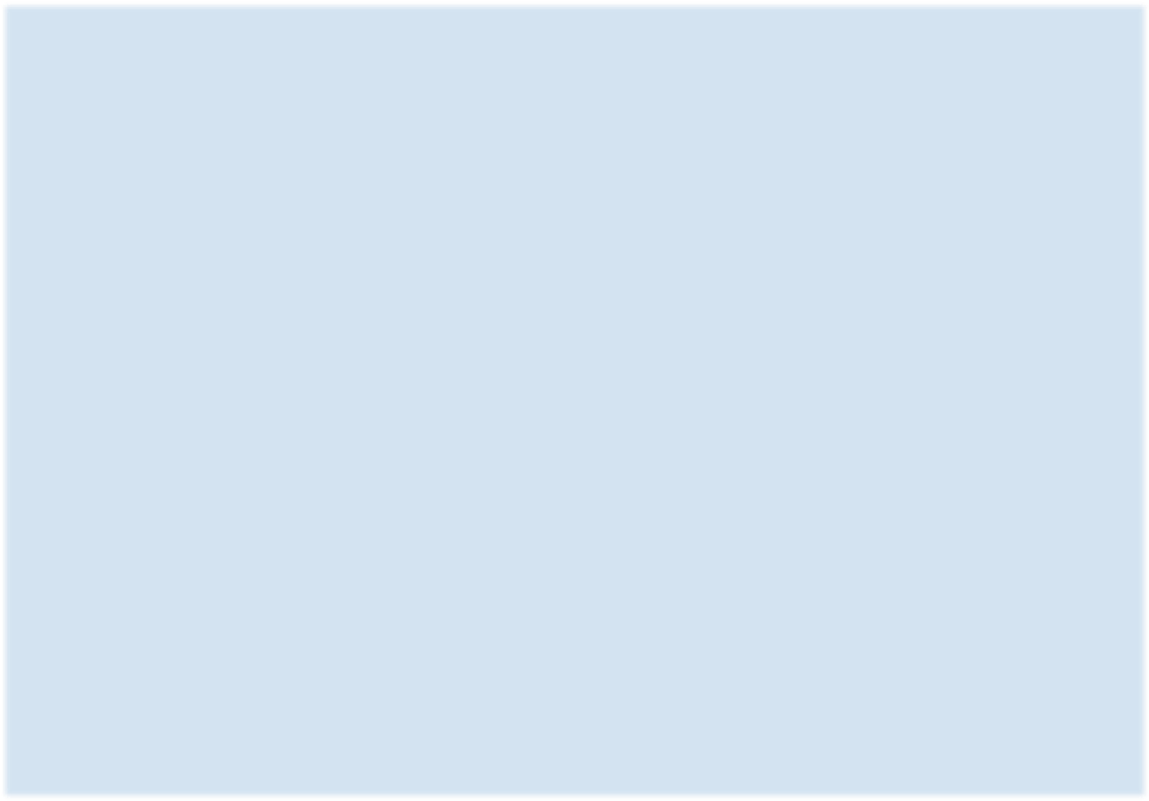

**PROCESS**

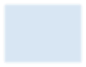

**SELECTION**



**START**

**/**

**END**



**INPUT**



**FOR**

**CREATING**

**GLOBAL**

**VARIBALES**



**BREAK FOR**

**SELCTIONS**



**FUNCTION**

**CALL**

**MENTION**

**FUNCTION**

**&**

**CLASS**

System Analysis

# Main Method

The flow diagram of the main method of the program is shown above. The user is asked to choose from

* Consulting the departments
* About Us Section
* Exit

After this selection, user is referred to the relevant process.

# Details

In this section program prompts the user for some required data like

* Patient Name
* Father Name
* Age
* Gender
* Address
* Contact Number

After this it generates the reference number for the user randomly. When the control comes to the gender section the flow is referred to the gender function.

# Details Check

In this section user is shown a layout with the data that is previously entered by the user. Then the user is prompted to check the data for any mistakes. If the user confirms that the given data is correct then flow is referred to Department section otherwise the flow is referred to the Details Overwrite section.

**Gender**

This section prompts the user for gender selection. And in case of wrong input it gives an error and repeat the prompt.

# Departments

The prompt in this section asks the user to select from a number of departments in the hospital and then based on the user’s choice the control is directed to relevant department.

# Details Overwrite

This section prompts the user to specify the wrong inputs and then overwrites it and then the control is directed to the ReAnnounceToOverWrite section.

# Re Announce To Overwrite

This section prompts the user to choose that does any other detail requires correctness. If yes then the control is directed to DetailsOverwrite section otherwise control is directed to DetailsCheck section.

# Eye

The user is asked in this section if the disease is already known or not. If yes then the program prompts the user upload the proof file. Otherwise the program is directed toward the EyeSymptoms and EyeResults.

# Eye Symptoms

The user is asked to answer a questionnaire regarding to symptoms of the eye problem. These symptoms include

* Eye Irritation
* Eye Itching
* Watering in eyes
* Burning
* Scaring in eyes • Redness

For each selection the value of a Boolean variable is set true or false. In case of wrong input the portion is repeated for valid choices.

**Eye Results**

This section informs the user about the disease and its treatment based on the given symptoms selection in the previous section.

# General

As the departments have the same procedure for the diagnosis and treatment of the diseases. Hence the same procedure is followed in all the departments section

# System Design

## Main Method

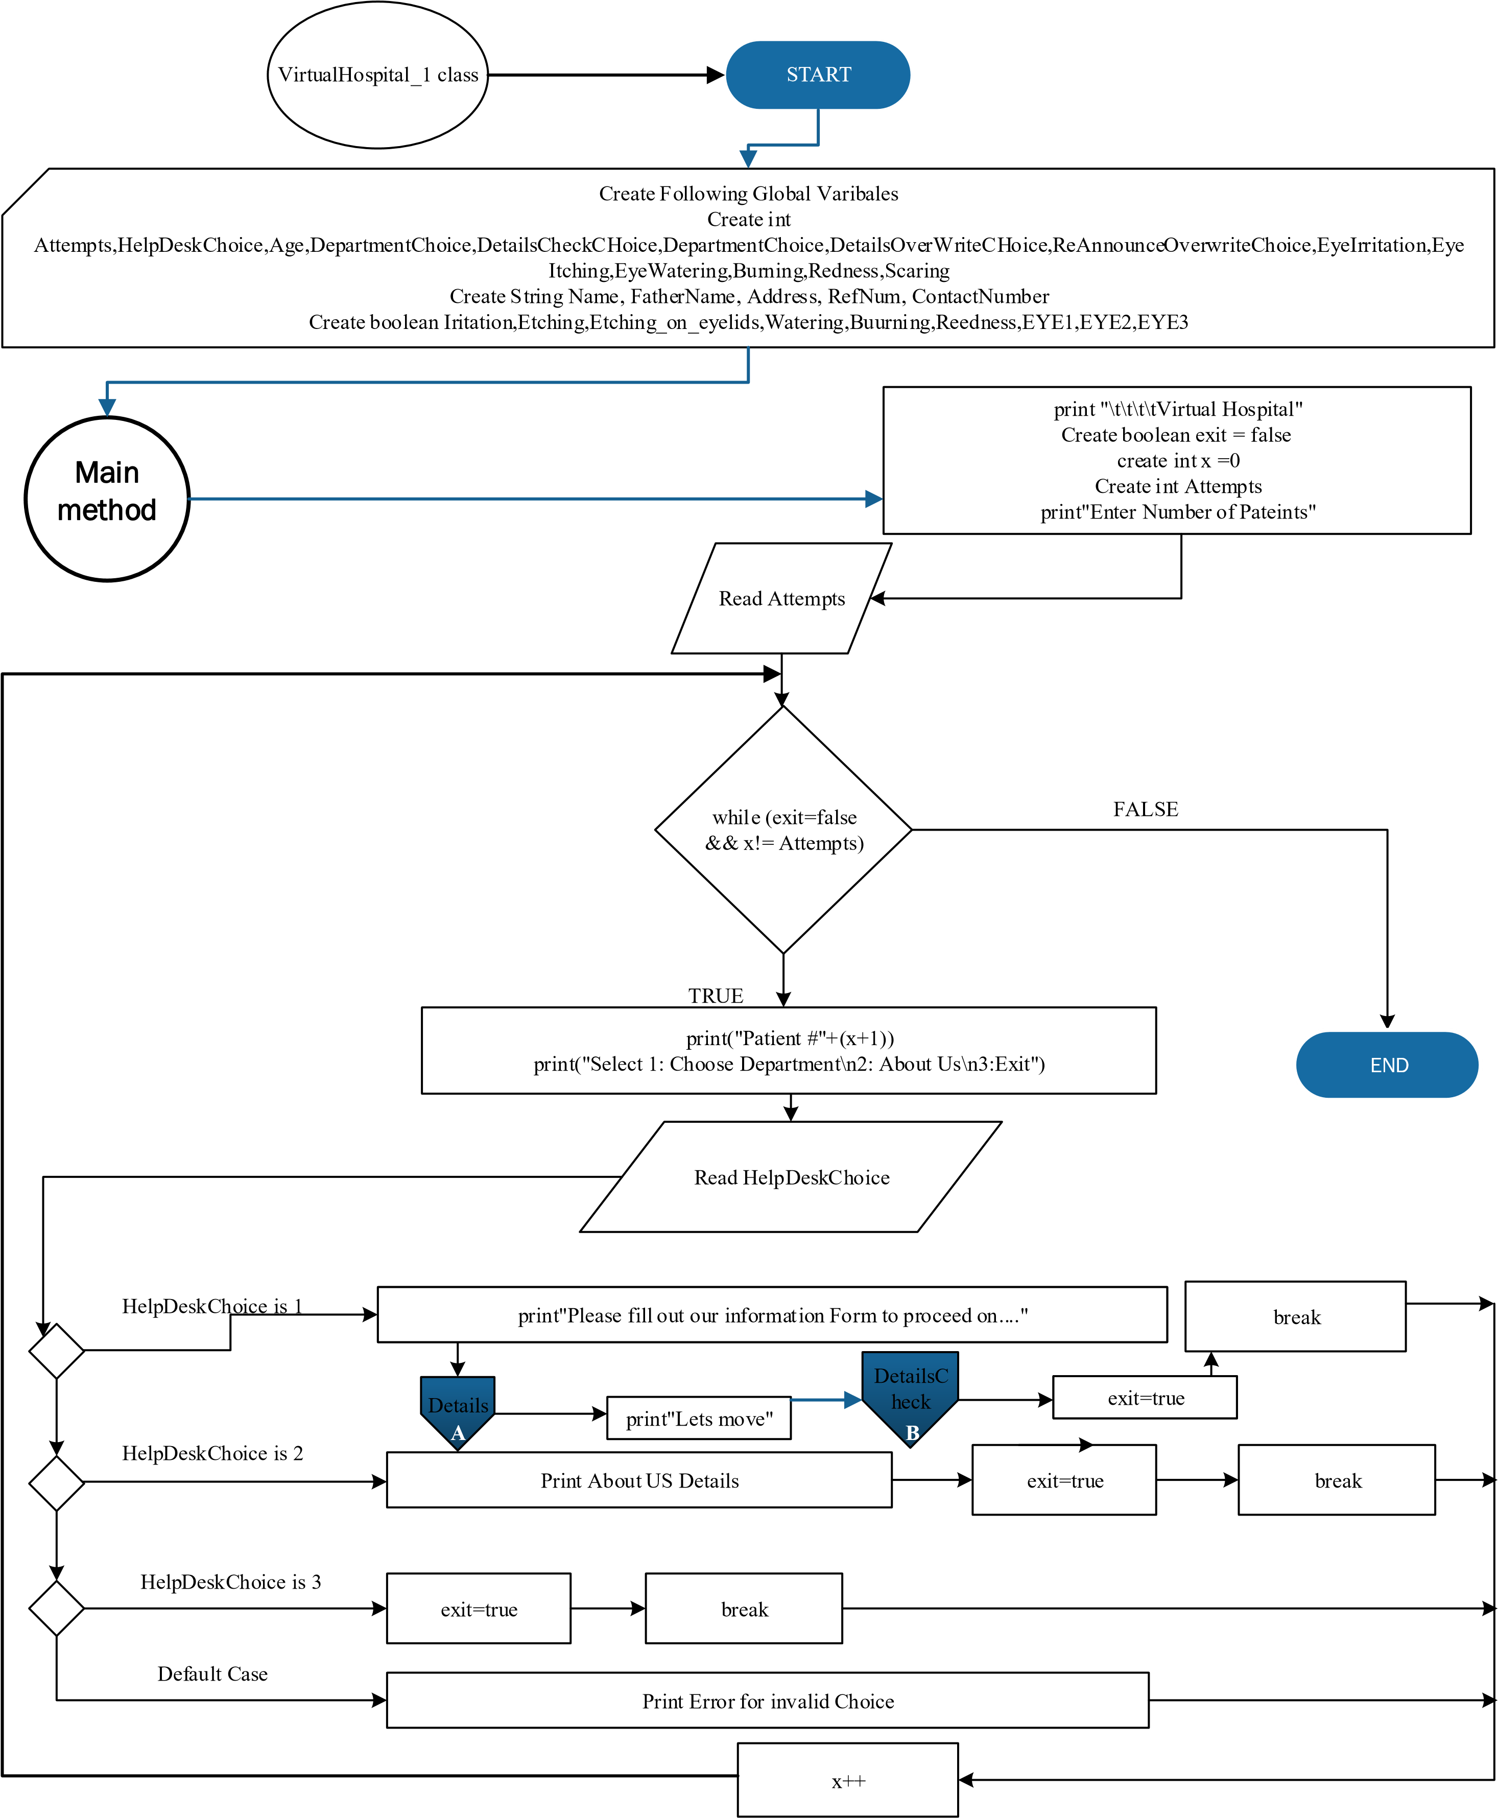

## Details



START

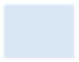

Prompt to enter

Patient Name



Read Name



Prompt to enter

Father Name



Read

FatherName



A

(

REFERNCED

ON PAGE

1

)



gender



Prompt User to

Enter Age



Read Age



Prompt user to

Enter Address



Read

Address



Prompt User to

Enter Contact

Number



Read

ContactNum

ber

C



Generate random

number between

0

and

10000000



Concatinate

HVH

with that generated

random number and

assign it to variable

RefNum



END

## Details Overwrite

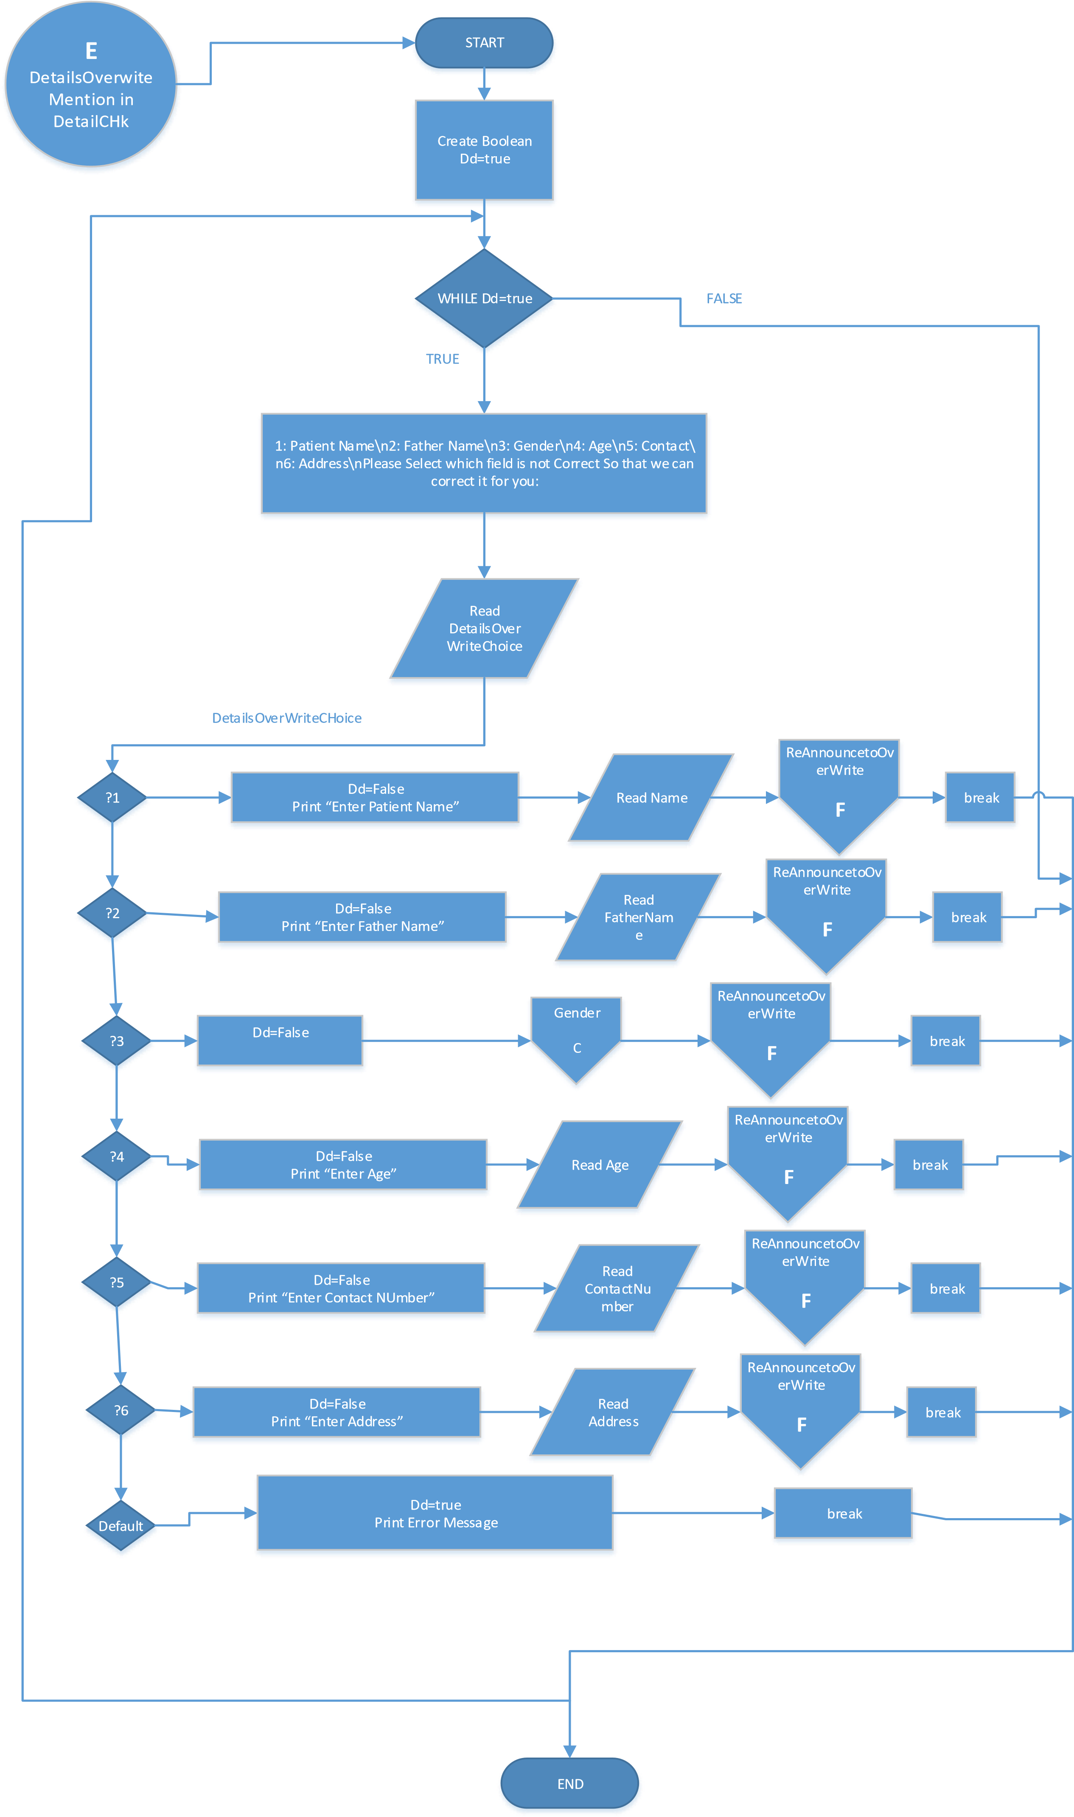

## Gender

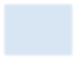

PROMT USER TO

CHOOSE ANY ONE

MALE FEMALE OR

NON SPECIFIED



READ

Gender



If

(

gender

<

3

or

<

1

)



WHILE

GENDER

!=

1

&

2

&

3



GENDER

C

MENTIONED ON PG

1



START



Give error message

of invaldi choice



END

true

false

true

false

## Details Check

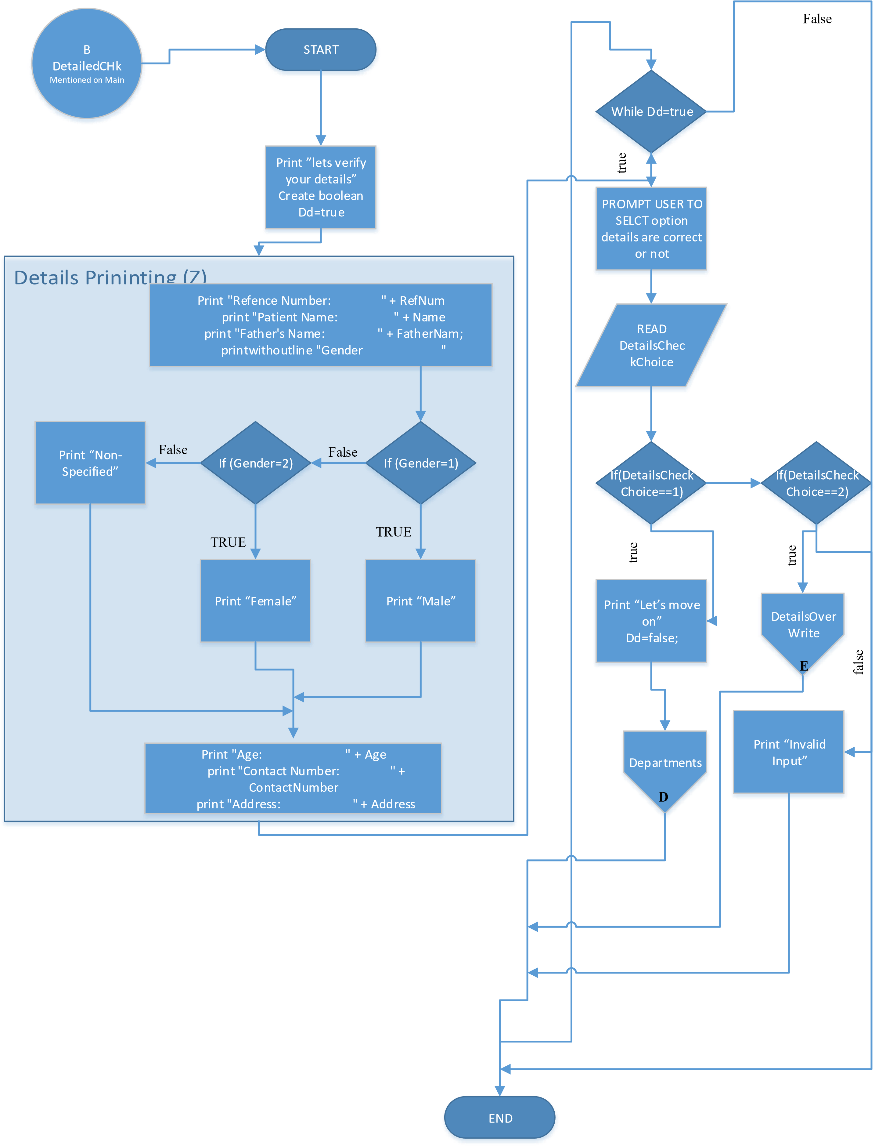

## Re Announce to Overwrite

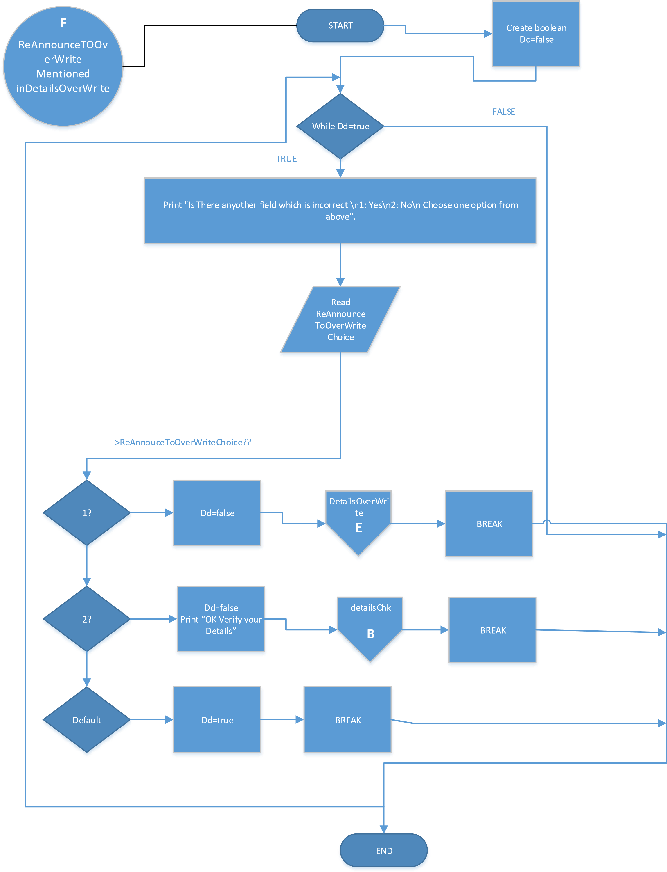

## Departments

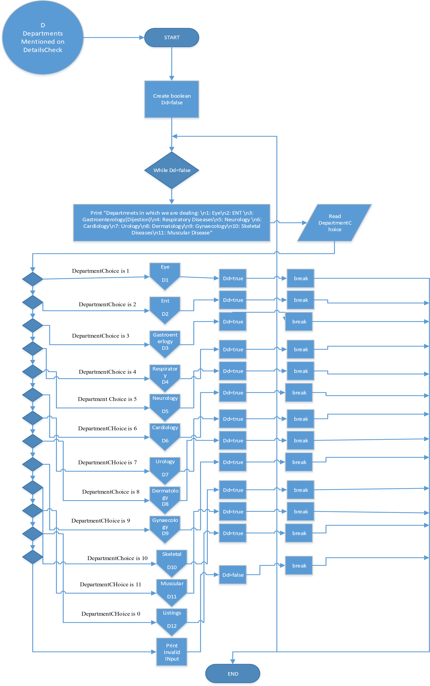

## Eye

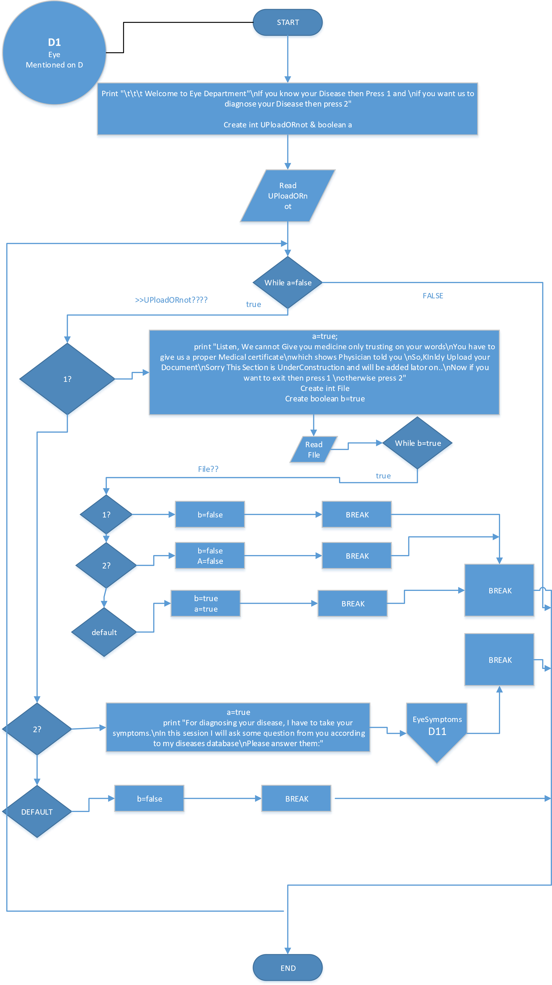

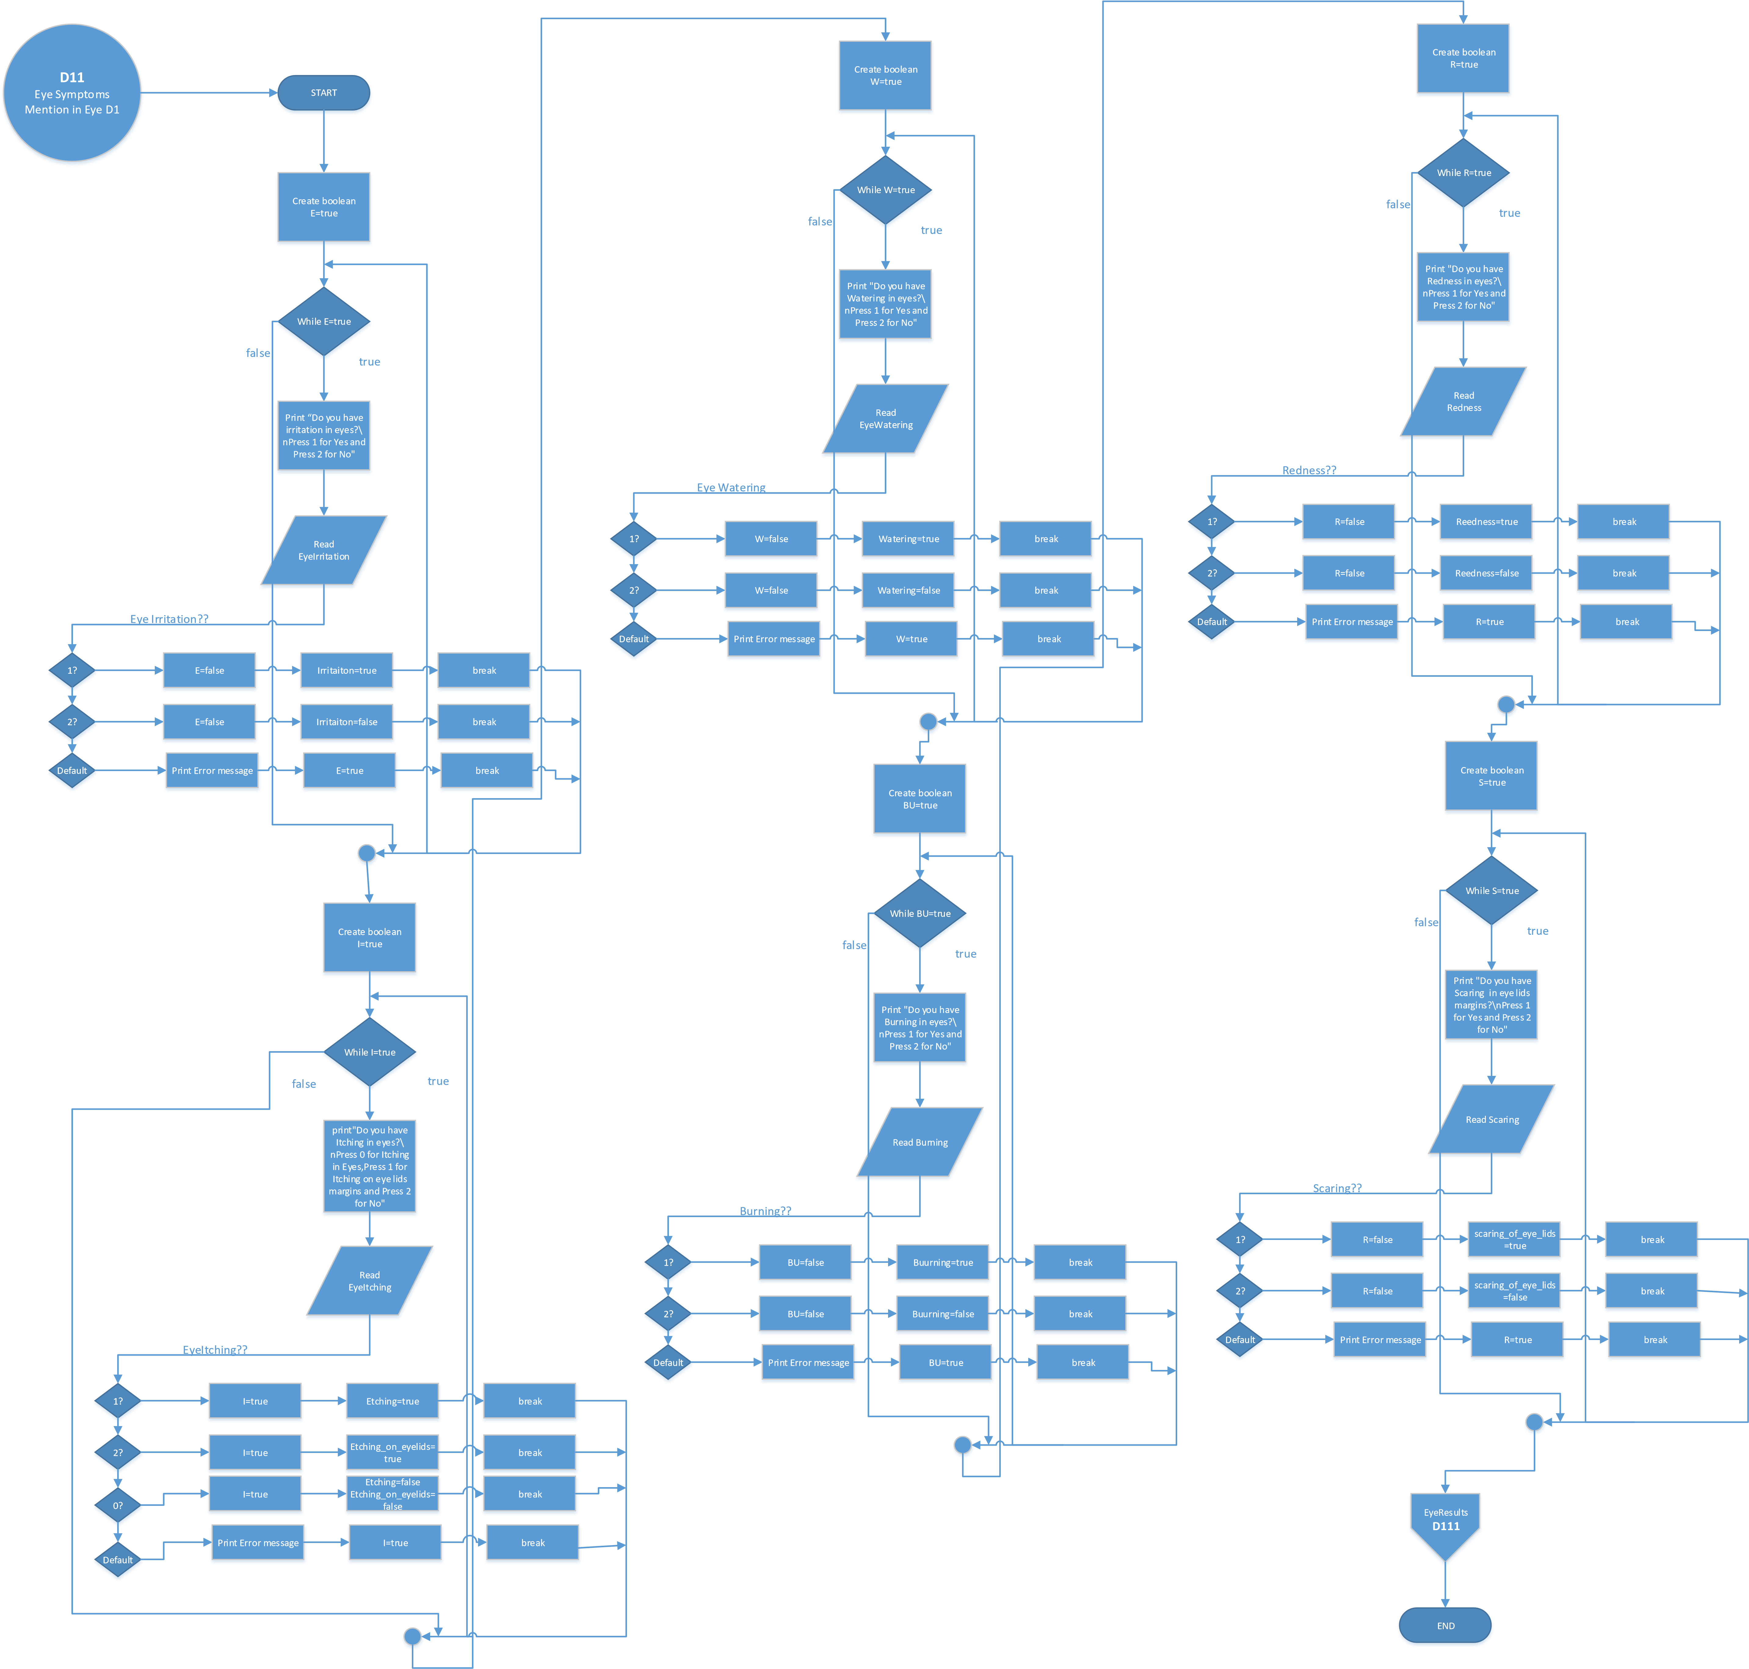

## Eye Results

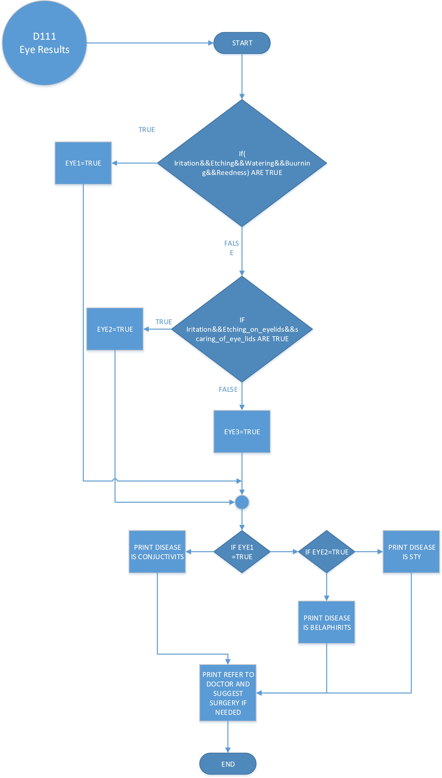

## General



Refer for All

Departments

almost same

phenomenon is in al

department



start



Symptoms



Results



end

Above are all the flow charts of the Virtual Hospital System.